Below is a general overview of the position along with a link to the job openings:

Position Overview

As an overview, our PMs bring to fruition new products and features that genuinely benefit our users while at the same time make good business sense. They act as general managers of our products, providing leadership across functional teams to conceptualize, build and deliver Google's next great app. PMs find our entrepreneurial culture to be exciting and challenging, because they are never stuck maintaining an existing product, but are instead focused on developing new product ideas and strategies.
We have openings across all of our products in areas such as Consumer, Mobile, Apps, Enterprise and Infrastructure to name a few. As a brief outline, we have an agnostic interview process in which we aim to hire PM "generalists", who may have niche experience but can easily float through our evolving product lines. We find this keeps our Product Managers fresh and with distributed, homogeneous experiences for our project teams. So, in a nutshell, we do not hire for a specific product, but rather, are seeking generalists who can work on multiple products. As such, you'll interview with PMs working on any number of our various products. At a later point, our leadership reviews your interests, background and interviews to identify relevant projects that align with business need.

PM Jobs Index

Product Manager YouTube Videos

====================================

To recap - please send me:
- An updated resume
- Availability for a 45-min call over the next 1-2 weeks (4-5 options please, between 10am-4pm, Mon-Fri PT) Submit times/dates using the format below, strictly listing availability in Pacific Time
  - Ex) 12/15: 10:00 AM- 4:00 PM PT
  - Ex) 12/16: 10:00 AM-2:00PM PT, 3:00PM-4:00PM PT
- List of internal references (optional) - please only share names of individuals who are currently employed by Google, are familiar with your current and/or prior work or educational performance(s), and will provide a positive reference. *If your reference has recently joined Google, please be cognizant as they may have non-solicits from your current company.

Below is some additional information to help you prepare. Please let me know if you have any questions!

Product Management Position Overview:

GCP Website - All product areas within Google Cloud Platform
G Suite Website - All product areas within gSuite
All Products at Google

As an overview, our PM's bring to fruition new products and features that genuinely benefit our users while at the same time make good business sense. They act as general managers of our products, providing leadership across functional teams to conceptualize, build and deliver Google's next great app. PM's find our entrepreneurial culture to be exciting and challenging, because they are never stuck maintaining an existing product, but are instead focused on developing new product ideas and strategies.
We have openings across all of our products in areas such as Consumer, Mobile, Apps, Enterprise and Infrastructure to name a few. As a brief outline, we have an agnostic interview process in which we aim to hire PM "generalists", who may have niche experience but can easily float through our evolving product lines. We find this keeps our Product Managers fresh and with distributed, homogeneous experiences for our project teams. So, in a nutshell, we do not hire for a specific product, but rather, are seeking generalists who can work on multiple products. As such, you'll interview with PM's working on any number of our various products. At a later point, our leadership reviews your interests, background and interviews to identify relevant projects that align with business need.
What to Expect
There are five components to the Google product manager (PM) interview:
- Product design. Google PMs put users first. PMs are zealous about providing the best user experiences.It starts with customer empathy and always includes a passion for products, down to the smallest details. They can sketch a wireframe to convey an idea to a designer. Sample questions include:

  - How would you improve Google Maps?

  - How would you reduce Gmail storage size?

  - How would you improve restaurant search?

  - What’s favorite Google product? What do you like or not like about it?

  - If you were to build the next killer feature for Google, what would it be?

  - You’re part of the Google Search web spam team. How would you detect duplicate websites?

- Analytical. Google PMs are fluent with numbers. They define the right metrics. They can interpret and make decisions from A/B test results. They don't mind getting their hands dirty. Sometimes they write SQL queries; other times, they run scripts to extract data from logs. They make their point by crisply communicating their analysis. Some examples of analytical questions:

  - How many queries per second does Gmail get?

  - How many iPhones are sold in the US each year?

  - As the PM for Google Glass 'Enterprise Edition,' which metrics would you track? How do you know if the product is successful?

- Culture. Google PMs dream of the next moonshot idea. They lead and influence effectively. They have a bias for action and get things done. If Google PMs were working anywhere else, they’d probably be CEOs of their own company. Sample questions:

  - Why Google?

  - Why PM?

- Technical. Google PMs lead product development teams. To lead effectively, PMs must have influence and credibility with engineers. During the final round (aka onsite) interview, a senior member of the engineering team will evaluate your technical competence. Example questions include:

  - Write an algorithm that detects meeting conflicts.

- Strategy. Google PMs are business leaders. As a result, they must be familiar with business issues. It’s not necessary for PMs to have business experience or formal business training. However, they do expect you to pick up business intuition and judgment quickly. Sample interview questions include:

- If you were Google’s CEO, would you be concerned about Microsoft?
- Should Google offer a Stubhub competitor? That is, sell sports, concert, and theater tickets?
Also be prepared for behavioral interview questions such as Tell me a time when you had to influence engineering to build a particular feature. Google PM interviewers are relying more on behavioral interview questions in recent months.

What Not to Expect
Brain teasers, such as logic puzzles, are rarely used in today’s Google PM interviews. Google’s HR department found a low correlation between job performance and a candidate’s ability to solve brain teasers. Examples of brain teasers include
- I roll two dice. What is the probability that the 2nd number is greater than the 1st?

- What’s 27 x 27 without using a calculator or paper?

How to Prepare
Here's what I'd recommend to get ready for the Google PM interview:

Visit thepminterview.com for GREAT example questions! If interested in having a coaching call with a Product Manager at Google, reach out to your recruiter to learn more.

Review tech blogs, such as: Stratechery.
- Product design. Practice leading design discussions using a framework. (Need a framework? Try CIRCLES Method™: http://qr.ae/i6kRM). Start with possible personas and detail use cases. Prioritize use cases and brainstorm solutions. Many PM candidates (wrongly) suggest solutions that are incremental or derivatives of a competitor’s feature set. The Google interviewers are evaluating your creativity, and they place a big emphasis on big ideas (aka “moonshots”). Inspire them with unique, compelling ideas.Drawing wireframes on a whiteboard will help illustrate your ideas. To practice, download a wireframing tool like Balsamiq. Also study popular web and mobile design patterns for inspiration.

- Technical. Coding questions are unlikely during the phone interviews. But if you are invited to an on-site interview, you must prepare for programming interviews. The technical interviewer does not expect your programming syntax to be perfect, but you should have sufficient mastery of technical concepts so that you can participate in technical discussions and help make technical trade-offs. I would recommend going over computer science fundamentals and practicing a couple coding questions. One of my favorite resources isHow to Ace the Software Engineering Interview. Also be prepared to describe key technologies including search engines, machine learning, and MapReduce.
- Analytical. Prepare for estimation questions such as How many queries per second does Gmail get? Get well-versed in product launch metrics and A/B testing, including interpretation of results.
- Strategy. Use a framework to structure your strategy discussions. If you’re not familiar with strategy or frameworks, Porter’s Five Forces is a good start.
Culture. Understand what it means to be Googley by reading Google’s corporate philosophy. Review Google’s Android design principles. Optional readings: Google’s visual asset guidelines and Steven Levy’s 2007 (but still useful) article on the Google APM Program. Another optional, but more in-depth (and recent) perspective, read Steven Levy’s "In the Plex: How Google Thinks, Works, and Shapes Our Lives."

===============================================

Position Overview

As an overview, our PMs bring to fruition new products and features that genuinely benefit our users while at the same time make good business sense. They act as general managers of our products, providing leadership across functional teams to conceptualize, build and deliver Google's next great app. PMs find our entrepreneurial culture to be exciting and challenging, because they are never stuck maintaining an existing product, but are instead focused on developing new product ideas and strategies.

We have openings across all of our products in areas such as Consumer, Mobile, Apps, Enterprise and Infrastructure to name a few. As a brief outline, we have an agnostic interview process in which we aim to hire PM "generalists", who may have niche experience but can easily float through our evolving product lines. We find this keeps our Product Managers fresh and with distributed, homogeneous experiences for our project teams. So, in a nutshell, we do not interview for a specific product, but rather, are seeking generalists who can work on multiple products. As such, you'll interview with PMs working on any number of our various products. At a later point, our leadership reviews your interests, background and interviews to identify relevant projects that align with business need, and when you are hired, you are hired on with a specific product team.

Meet PMs at Google

===================================================

Notes from google recruiter call before the phone screening:

- Expect questions on technology
- No coding will be asked
- Example questions
  - Design a paper cup for multiple use cases
  - Design a clock for the blind
  - Estimation question - how many iphones are sold each year
  - Basic network, hashtable, data-structure
- This is a generalist role, I can choose between Cloud or Consumer. I opted consumer
- What they look for
  - Creativity
  - Innovative ideas
  - NO to replicated or incremental ideas. Go moonshot, but back up it up theory and risks
- Answer questions with the following
  - Analyze problem
  - Follow structure & mention approach
  - Breakdown the problem
  - Always ask clarifying questions (google encourages this)
  - If you need to take a moment to think do that (Silence is good)
  - Voice the USERS
  - Don’t just think - say out loud your assumptions
  - Don’t forget the edge cases
- Phone interview will be from a person who is more senior than I am
- Read the book - Cracking the PM interview
- Practice at https://thepminterview.com/
- After phone interview a new recruiter will be assigned. In some small case a second interview will take place

========================================
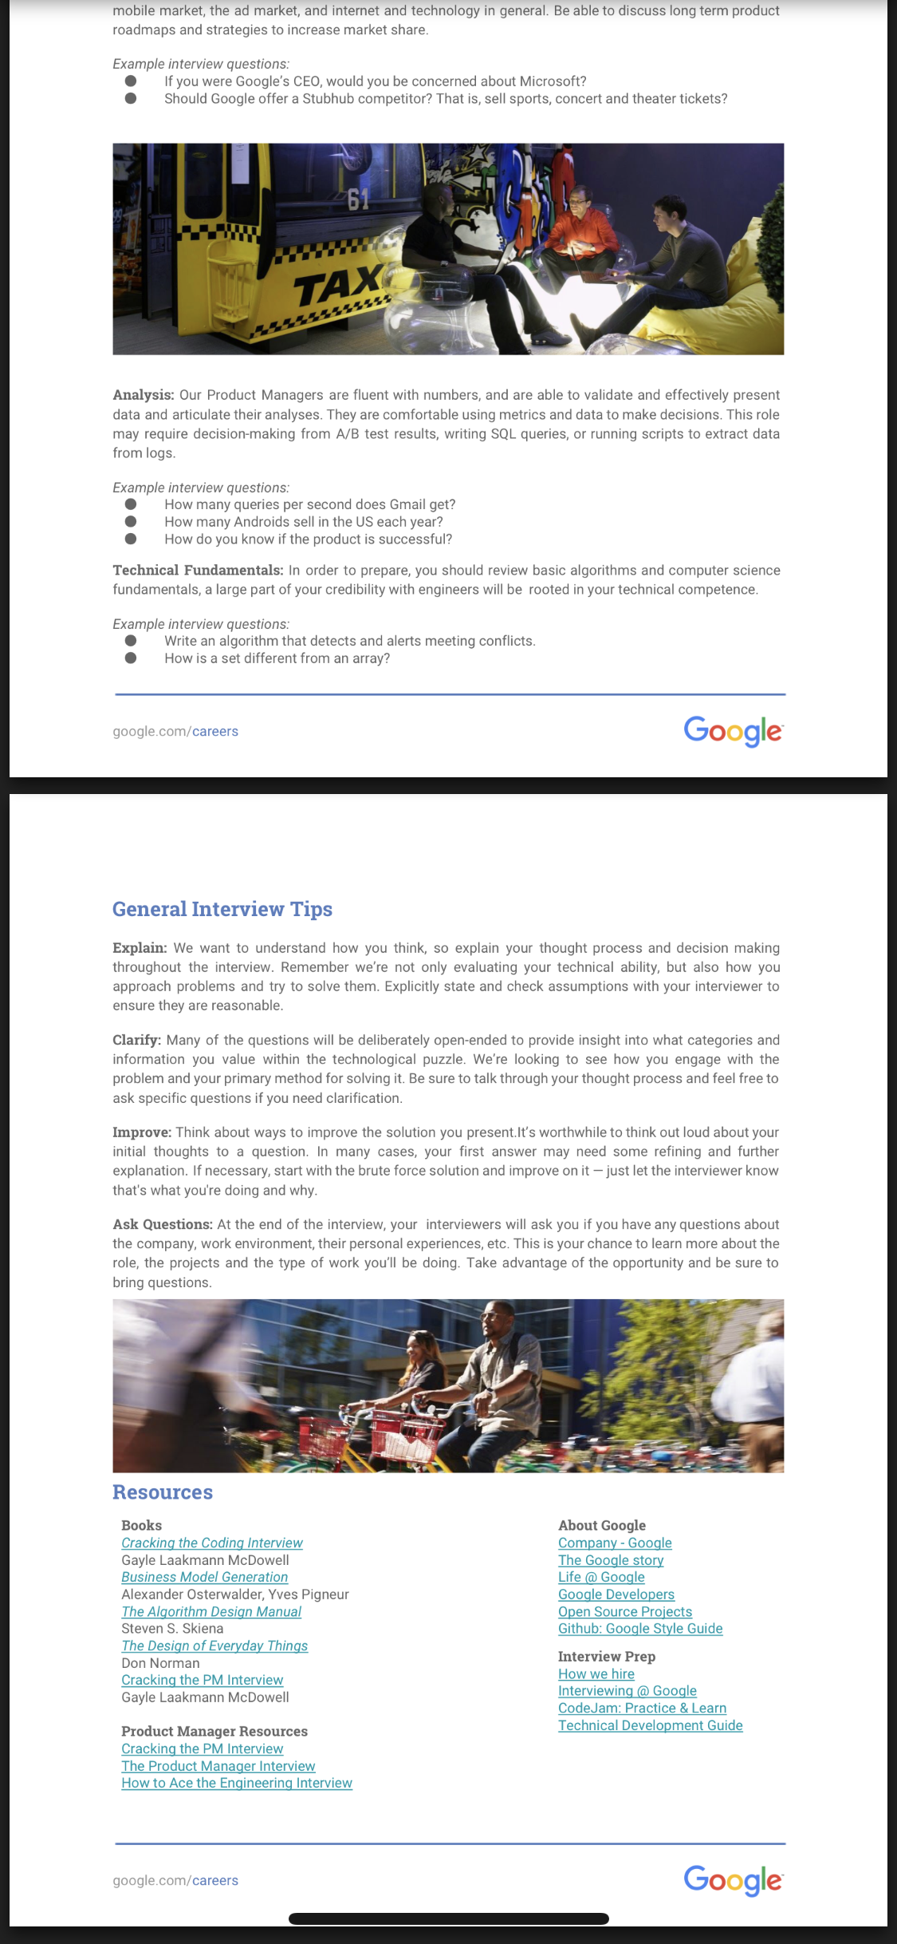


==============
Hi Vikash,
We’re excited to welcome you to our Google campus for onsite interviews! I’m working with Julie Tomaszewski and have scheduled your interviews as follows:
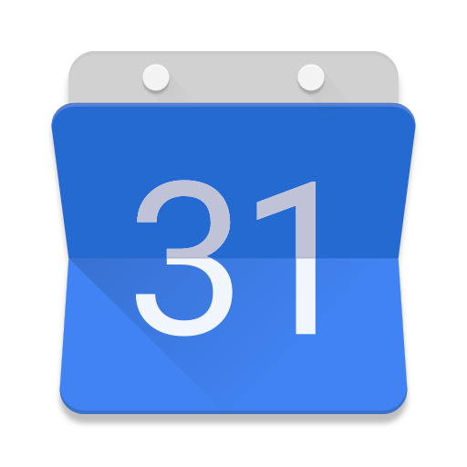 | Date: Tuesday, October 2nd, 2018  Interview Time: 10:00am - 2:45pm PST (includes lunch)
Please arrive 15 minutes in advance of your interviews and check in at reception.
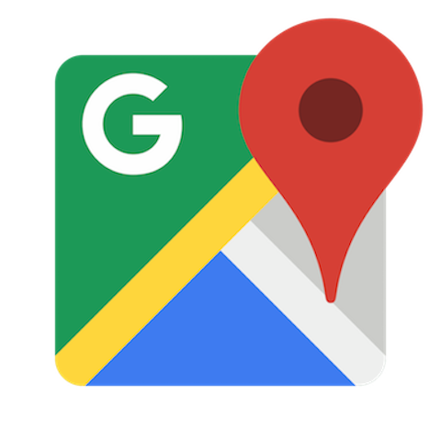 | Where to go:  Google Inc., Building CL4, 1400 Crittenden Ln, Mountain View, CA 94043. Please bring a form of government-issued photo identification such as a driver’s license or passport to verify your identity. If you arrive early, feel free to kick back and relax in the lobby - we have free Wi-Fi!  Parking: There are designated visitor spots near the building entrances, but feel free to park anywhere if those are filled; no parking permit is required. If you have trouble finding a spot, check out our complimentary valet stations.
Get ready for your interview:
- Let us know you can make it by replying all to confirm your interview time.
- Complete our Employment Application (by today if you can!). Though it shouldn’t take more than 20 minutes, please take your time if needed. We recommend that you complete it in one sitting as the session will expire without saving if it remains open for a long period of time. Most importantly, please carefully review your information to ensure everything is accurate, thorough, and complete.
- It’s important to us to create an inclusive workplace for everyone, so please reach out if you’d benefit from interview accommodations, like a sign language interpreter, specialized equipment, or a lactation room break. We’ll then connect you with our candidate accommodations team to confidentially discuss your options.
- Have questions about getting to your interview? Ask me, I'm an expert!
As a friendly reminder, our interview questions are confidential, so please keep things under wraps.
You may see up to two Googlers shadowing your interview for training purposes. Not to fear—they are perfectly friendly! Please reach out to your recruiter with any questions or concerns.
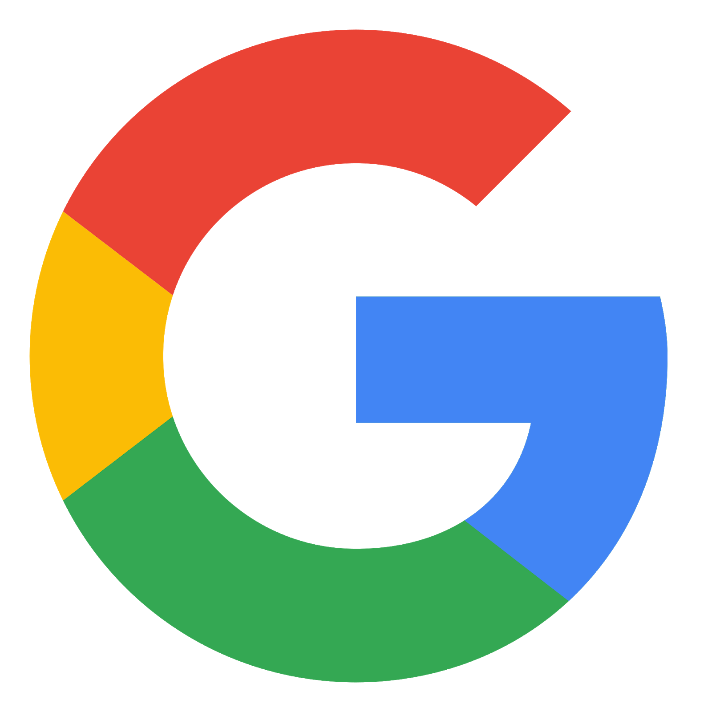 | Scheduling Questions?  If you need to reschedule due to an unforeseen emergency, we’re here to help. Please note this may delay your interview process.
Thank you!
Glenn

 | Glenn Avisado  Staffing Services Associate, Recruiting (Americas)  +1 650-214-7306  careers.google.com  
=========================================

Hi Vikash,
We were able to reschedule your interview with details below:
 | Date: Tuesday, October 16th, 2018  Interview Time: 11:15am - 4:00pm PST (includes lunch)
Please arrive 15 minutes in advance of your interviews and check in at reception.
 | Where to go:  Google Building CL2, 1200 Crittenden Ln, Mountain View, CA 94043. Please bring a form of government-issued photo identification such as a driver’s license or passport to verify your identity. If you arrive early, feel free to kick back and relax in the lobby - we have free Wi-Fi!  Parking: There are designated visitor spots near the building entrances, but feel free to park anywhere if those are filled; no parking permit is required. If you have trouble finding a spot, check out our complimentary valet stations.
Get ready for your interview:
- Let us know you can make it by replying all to confirm your interview time.
- Complete our Employment Application (by today if you can!). Though it shouldn’t take more than 20 minutes, please take your time if needed. We recommend that you complete it in one sitting as the session will expire without saving if it remains open for a long period of time. Most importantly, please carefully review your information to ensure everything is accurate, thorough, and complete.
- It’s important to us to create an inclusive workplace for everyone, so please reach out if you’d benefit from interview accommodations, like a sign language interpreter, specialized equipment, or a lactation room break. We’ll then connect you with our candidate accommodations team to confidentially discuss your options.
- Have questions about getting to your interview? Ask me, I'm an expert!
As a friendly reminder, our interview questions are confidential, so please keep things under wraps.
You may see up to two Googlers shadowing your interview for training purposes. Not to fear—they are perfectly friendly! Please reach out to your recruiter with any questions or concerns.
 | Scheduling Questions?  If you need to reschedule due to an unforeseen emergency, we’re here to help. Please note this may delay your interview process.
Thank you!
Glenn

 | Glenn Avisado  Staffing Services Associate, Recruiting (Americas)  +1 650-214-7306  careers.google.com  

Google Product Management: Next Steps
Maria Alam | Apr 2, 2020, 7:51 AM
to me

Great connecting yesterday, Vikash

To recap - please send me:
- Updated resume
- List of internal references - please only share names of individuals who are currently employed by Google, are familiar with your current and/or prior work or educational performance(s), and will provide a positive reference. *If your reference has recently joined Google, please be cognizant as they may have non-solicits from your current company.
- Availability for a 45-min call over the next 2 weeks(4-5 options please, between 10am-4pm, Mon-Fri PT)Submit times/dates using the format below, strictly listing availability in Pacific Time
  - Ex) 12/15: 10:00 AM- 4:00 PM PT
  - Ex) 12/16: 10:00 AM-2:00PM PT, 3:00PM-4:00PM PT

Below is some additional information to help you prepare. Please let me know if you have any questions!

Product Management Position Overview:

https://careers.google.com/jobs/results/138703388230460102/

GCP Website - All product areas within Google Cloud Platform
G Suite Website - All product areas within gSuite
All Product at Google

As an overview, our PM's bring to fruition new products and features that genuinely benefit our users while at the same time make good business sense. They act as general managers of our products, providing leadership across functional teams to conceptualize, build and deliver Google's next great app. PM's find our entrepreneurial culture to be exciting and challenging, because they are never stuck maintaining an existing product, but are instead focused on developing new product ideas and strategies.
We have openings across all of our products in areas such as Consumer, Mobile, Apps, Enterprise and Infrastructure to name a few. As a brief outline, we have an agnostic interview process in which we aim to hire PM "generalists", who may have niche experience but can easily float through our evolving product lines. We find this keeps our Product Managers fresh and with distributed, homogeneous experiences for our project teams. So, in a nutshell, we do not hire for a specific product, but rather, are seeking generalists who can work on multiple products. As such, you'll interview with PM's working on any number of our various products. At a later point, our leadership reviews your interests, background and interviews to identify relevant projects that align with business needs.
What to Expect:
Interviewing @ Google

Phone Interview: Your ~45 minute phone interview will be with another Product Manager. During this process, the interview will focus primarily on questions that assess your experience in product design & strategy and your analytical abilities (see more details below about each of these components). It is important to note that while there may be a few questions about your background and previous experiences, the majority of the interview will focus on how you think, how you approach problems, how creative you are, etc. Sample Questions: How would you design an alarm clock for a visually impaired person; Estimate the number of vacuums sold in the U.S. every year.

Onsite Interview
There are five components to the Google product manager (PM) onsite interview:
- Product Design & Strategy. Google PMs put users first and think creatively and critically about technical products. PMs are zealous about providing the best user experience. It starts with customer empathy and always includes a passion for products, down to the smallest details. Google PMs are also business leaders. As a result, they must be familiar with business issues. It’s not necessary for PMs to have business experience or formal business training. However, there will be a focus on business intuition and judgement even when you may not have all of the possible data available. Furthermore, you’ll be expected to design products with a broader strategic vision. Sample questions: How would you improve Google Maps? If you were to build the next killer business for Google, what would it be? Tell me about Cloud. What are the major trends, and what do you foresee as the future of Cloud?
- Analytical. Google PMs are fluent with numbers. They define the right metrics. They can interpret and make decisions from A/B test results. They don't mind getting their hands dirty. Sometimes they write SQL queries; other times, they run scripts to extract data from logs. They know what questions to ask, how to structure problem solving, and what type of data they need to make decisions. They make their point by crisply communicating their analysis. Sample analytical questions: How many iPhones are sold in the US each year? How many queries per second does Gmail get? Most important in answering analytical questions is attention to detail and communication of how you’d break the problem into smaller nuggets to reach an overall solution.
- Googleyness & Leadership. Google PMs have a unique ability to get things done, do the right thing and put users first, all while striving for self development. Expect behavioral questions (ex: Tell me about a time or give me an example of...) that demonstrate your ability to work effectively with others, thrive in ambiguity and effectively challenge the status quo. Be prepared to discuss how you have used your communication and decision-making skills to mobilize others. This might be by stepping up to a leadership role at work or with an organization, or by helping a team succeed even when you weren’t officially the leader. Share how you work individually and on a team, how you help others, how you navigate ambiguity, and how you push yourself to grow outside of your comfort zone.
- Domain Interview: Candidates interested in joining Google Cloud Platform (which includes Cloud Infrastructure, G Suite, Developer Platform Group, Unified Fulfillment Optimization, etc) will be expected to demonstrate knowledge in an applicable domain. Candidates will select a domain area they feel most comfortable in (Compute, SaaS, Big Data, Security & Privacy, Dev and Ops, Machine Learning, Data Centers, etc) and one Product interview will focus primarily on this topic. Expect questions on core concepts related to the domain area. Be prepared to discuss your experience and knowledge in the field. Also be prepared to discuss key competitors, industry trends and ideas on how to improve existing products.
- Technical. Our PMs bridge the gap between the engineering and business side. One of your interviews will be with an engineer who will evaluate your technical abilities within an applicable domain area of your choice. Example domain areas include: SaaS architecture, Compute, Cloud Storage, Applied ML, Virtual Machines, Databases, Open source tools (Hadoop/Spark), SDKs/APIs, etc. Candidates are expected to demonstrate technical knowledge in only ONE domain area, and it is up to the candidate to select the area they are most comfortable in.
How to Prepare
Here's what I'd recommend to get ready for the Google PM interview:

- Product Design & Strategy. Practice leading design discussions using a framework. Start with possible personas and detail use cases. Prioritize use cases and brainstorm solutions. Many PM candidates (wrongly) suggest solutions that are incremental or derivatives of a competitor’s feature set. The Google interviewers are evaluating your creativity, and they place a big emphasis on big ideas (aka “moonshots”). Inspire them with unique, compelling ideas. Drawing wireframes on a whiteboard will help illustrate your ideas. To practice, download a wireframing tool like Balsamiq. Also study popular web and mobile design patterns for inspiration. Use a framework to structure your strategy discussions. If you’re not familiar with strategy or frameworks, Porter’s Five Forces is a good start.
- Analytical. Prepare for estimation questions such as How many queries per second does Gmail get? Get well-versed in product launch metrics and A/B testing, including interpretation of results.
- Domain Knowledge. Familiarize yourself with the Google products which are mostly closely linked to your domain expertise. (Here’s a great resource that shows all GCP products in 4 words or less). Expect discussions, both technical and product, to be covered in depth for the domain area in which you are being evaluated.
- Technical. The technical interviewer does not expect your programming syntax to be perfect, but you should have sufficient mastery of technical concepts so that you can participate in technical discussions and help make technical trade-offs. We recommend reviewing computer science fundamentals. One potential resource you can use is How to Ace the Software Engineering Interview. Also be prepared to describe key technologies including search engines, machine learning, and MapReduce.

Additional Resources
- Visit thepminterview.com for example questions
- Practice sample PM interview questions https://www.interviewama.com/pm/
- Swipe to Unlock
- What are the basics of the Product Management Role by Google PM
- Working at Google as a Cloud PM at Google
- Google Cloud Next ‘18 in under 12 minutes
- Review tech blogs, such as: Stratechery.
- Meet Product Managers at Google
- How to Crack the Product Manager by Gayle McDowell (author of "Cracking the PM Interview"). Slides if you want to follow along with the video
Cloud PM Domains:

AI-ML Product Strategy and Market Knowledge
● Application Performance Monitoring (APM)
● Billing
● Compute
● Data Governance and Discovery
● Data Warehousing
● Databases
● Dev Tools-Platforms-SDKs
● DevOps
● Generalist
● Hadoop and Spark (Open Source)
● IAM
● Identity
● Internal Tools and Infrastructure Management
● Machine Learning
● Marketplace-Commerce
● Mobile
● Networking
● Ops Tools
● Privacy
● Production Data-ML Pipelines
● SaaS
● Security
● Serverless
● Storage

--
 | Maria Alam  Sourcer (Product Management)  1 (737) 236-1655 (Central Time Zone)  careers.google.com  

--
 | Maria Alam  Sourcer (Product Management)  1 (737) 236-1655 (Central Time Zone)  careers.google.com  

